User’s manual
Wheelchair
AT52310

WARRANTY CARD
Model: . . . . . . . . . . . . . . . . . . . . . . . . . . . . . . . . . . . . . . . . . . . . . . . . . . . . . . . . . . . . . . . .

Serial number: . . . . . . . . . . . . . . . . . . . . . . . . . . . . . . . . . . . . . . . . . . . . . . . . . . . . . . . . . .
Point of sale stamp
and a legible signature of the Seller: . . . . . . . . . . . . . . . . . . . . . . . . . . . . . . . . . . . . . . . . . . .

1) ANTAR Sp. J., 03-068 Warsaw, ul. Zawiślańska 43, hereby grants a 12-month warranty on the product, starting from the date of purchase by the Buyer.
2) During the warranty period ANTAR undertakes to carry out the repairs necessary to restore proper functioning of the product, within 14 days from the date of receipt of the product by the service centre together with the proof of purchase and the warranty card.
3) ANTAR reserves the right to replace the product if the repair is deemed uneconomic. Repair or replacement of faulty products does not extend the warranty period.
4) If the product is found to be malfunctioning, send it immediately to ANTAR (as specified in point 1) or contact the point of sale.
5) Before use, read the instructions carefully and follow them. If the product is used improperly and contrary to recommendations, the warranty will be irrevocably lost.
6) The warranty does not cover damage caused by external mechanical force, load exceeding the maximum permissible weight of the user as described in the manual, as well as contact of the product with alcohol, greasy substances or petrol. The warranty does not cover parts subject to normal wear and tear during use, such as the bearing, rubber parts and others.
7) THIS WARRANTY IS ONLY VALID TOGETHER WITH THE PROOF OF PURCHASE (BILL, RECEIPT, INVOICE). IN CASE OF A COMPLAINT, A PROOF OF PURCHASE MUST BE ATTACHED.
8) Complaints submitted without the proof of purchase and a warranty card with the product serial number will not be considered.




ANTAR Sp. J.
03-068 Warszawa, ul. Zawiślańska 43
Polska
Tel. +48 22 518 36 00, Fax +48 22 518 36 30 www.antar.net e-mail:antar@antar.net | v.1-23.07.2020
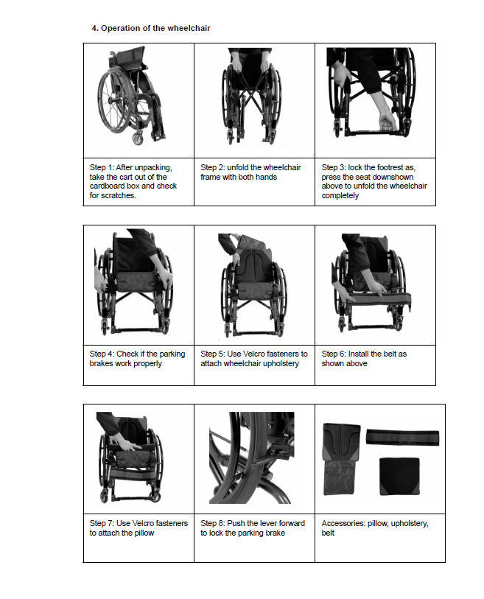
After unpacking make sure that all components do not have visible mechanical damages, otherwise please contact the manufacturer.
2. Safety rules
1) Get in and out of the wheelchair when the brakes are adjusted and applied; 2) Do not use the brakes during wheelchair use (they should be used only when the wheelchair is stopped)! This does not apply to the handbrake used by the person pushing the wheelchair (models with this option).
- When leaning forward please make sure that your weight does not move too much forward. To increase stability of the wheelchair please make sure, before leaning forward, that front wheels are set in the direction of travel!
- Do not lean forward too much and do not lean to the sides beyond the contour of the cart!
- The wheelchair can only be used on surfaces where all four wheels of the cart touch the ground and this contact allows the wheels to be driven.
- The wheelchair should be moved by gripping the frame structure. Never move the wheelchair by grabbing the other parts.
- It is forbidden to use the product if any visible or perceptible damages have been found, or degree of wear and tear of the components indicates potential risk of the accident (wheels wear and tear, damages, upholstery damages).
- Special care should be taken during folding/unfolding of the wheelchair; careless operation can lead to fi ngers being trapped by the moving components of the wheelchair.
- Do not stand on footrests when getting in and out of the wheelchair - it can lead to tipping over of the wheelchair;
ATTENTION: STANDING ON FOOTRESTS CAN LEAD TO TIPPING OVER AND INJURIES!
- Pay special attention during driving over the sills or other obstacles while transferring the entire weight on the rear wheels. If you are not sure whether this operation can be carried out safely you must absolutely ask somebody for help.
NOTE: CARELESS OR IMPROPER TRANSFERRING OF BODY WEIGHT TO THE REAR WHEELS CAN LEAD TO TIPPING THE WHEELCHAIR BACKWARDS WHAT CAN BE VERY DANGEROUS AND CAUSE SERIOUS INJURIES! IF YOU ARE NOT SURE WHETHER THIS OPERATION CAN BE CARRIED OUT SAFELY YOU MUST ABSOLUTELY ASK SOMEBODY FOR HELP.
- During moving be careful not to let your fi ngers get between the spokes. This can lead to hand injury.
- Special care should be taken on slopes to avoid excessive acceleration of the wheelchair. If the slopes cannot be overcome safely then it is absolutely necessary to ask another person for help.
- Avoid contact of the wheelchair with open fi re. In case of direct contact of textiles, plastic and rubber components with fi re, they may catch fi re.

3. Operation and maintenance
- the wheelchair has a foldable frame - it is folded by pulling the central part of the seat upwards and unfolded by pressing the sides of the seat downwards. Make sure that the sides of the seat rest exactly in the plastic clamps. Inaccurate unfolding can lead to cracking of the hooks and damage to the wheelchair.
- periodically check conditions of the wheelchair and maintenance by:
- inspection of tyres conditions - replace them if they are strongly worn out;
- inspection of tightness of the fasteners (bolts);
- removal of dirt from the wheelchair with a damp cloth;
- cleaning of upholstery with a damp cloth, possibly with mild cleaning agents;
- to keep the performance of the product is it very important to keep all components of the wheelchair clean and to store it properly. Storing the wheelchair in very humid rooms (laundries, baths) or in the open will cause wheelchair performance to deteriorate quickly.
- Do not expose wheelchair to extreme weather conditions (rain, sun, snow).
- it if forbidden to use solvents, agents with chlorines, sharp brushes, or other objects for cleaning or corrosive cleaning agents.
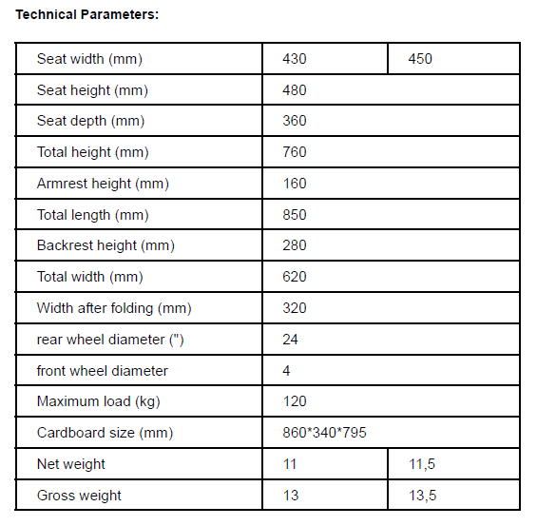
5. Driving the wheelchair
When using the wheelchair, put your hands so that the thumb is placed along the upper part of the
wheel and the fi ngers hold the bottom part of the wheel. This ensures a strong grip and the ability to quickly release the wheels. Hold the wheels at the height of the backrest and vigorously push them forward. There is a pushrim around the wheels, which makes it easier to push the wheels. After pushing, move the hands back to the starting position so that they form a circle. This ensures that the shoulders and arms do not work during the return movement. Do not move the hands back to the starting position along the pushrim. The wheelchair is designed so that the main load is on the rear (large) wheels. This makes the front (small) wheels bear less load, preventing them from being damaged. This design, however, poses a certain risk of tipping the wheelchair over while navigating ramps, slopes, or obstacles if safety instructions are not followed. Therefore, please read carefully the instructions contained in points „Safety rules“ and „Overcoming obstacles“.
6. Overcoming obstacles:
- when choosing the wheelchair, consult a doctor in order to purchase the best model.
- if, for any reason, you are unable to navigate an obstacle when using the wheelchair, ask for help.
Attempts to navigate an obstacle on your own may result in tipping the wheelchair over and injury. - most user can navigate small obstacles on their own;
- moving down a small threshold (e.g. a kerb) – position yourself in front of the threshold, perpendicularly to the threshold axis, make sure that the footrests do not touch the ground, and move down the threshold. Avoid leaning forward;
- moving down a large threshold (e.g. a kerb) – position yourself with your back to to the threshold axis, lean forward, move the centre of gravity forward, then move down the obstacle, controlling movement speed by holding the pushrims with your hands;
- always ask for help when navigating steep obstacles or the stairs;
- moving up a threshold requires training and strength from the user. Transfer your entire body weight to the rear wheels and climb a step by pushing the pushrims with your hands and balancing your body. The wheelchair should be positioned perpendicularly to the obstacle. Balance your body to put the front wheels on the obstacle, then transfer the body weight forward (by leaning forward) and move up the obstacle by pushing the pushrims. In case of steep slopes and high obstacles, always ask for help. The helper puts one leg on one of the tubes under the wheelchair, tilts the wheelchair backwards, and then climbs the obstacle. - when navigating slopes, be careful not to lose control of the wheelchair. Always control the wheelchair speed and do not let it accelerate. If you have any doubts as to being able to navigate a slope safely, always ask another person to help you.

