 |  |  |  |  |  |  |  |  |  |  |  |  |  | PCS 100537
EUROPEAN UNION (BIOCIDAL PRODUCTS) REGULATIONS
BIOCIDAL PRODUCT NOTIFICATION
 | The Department of Agriculture, Food and the Marine as the Competent Authority for Biocides in Ireland, pursuant to Regulations 9 and 10 of the European Union (Biocidal Products) Regulations 2013 (S.I. 427 of 2013), hereby declare that the Notification Holder:
 | ZATORI RESULTS LTD
 | T/A THE MOBILITYSHOP.IE, CLONMINAM BUSINESS PK, PORTLAOIS
 | has notified the biocidal product:
 | Symsave Instant Hand Sanitiser
 | to the Competent Authority for Biocides in order to make available on the market in Ireland.
 | It is the responsibility of the Notification Holder to ensure that: the product label(s) and safety data sheets are in compliance with the relevant Regulations; changes to the product are notified to the Competent Authority for Biocides in Ireland prior to the change to the product. Where the product is classified under the CLP Regulation as hazardous on the basis of its health or physical effects, information on the product must be supplied to the National Poisons Information Centre of Ireland (NPIC) before product is made available on the market or where changes to the product name, composition or CLP classification occur.
 | Product Summary
 | Product Name: |  |  | Symsave Instant Hand Sanitiser |  |  |  |  | PCS No: |  | PCS 100537
 | Formulation Type: |  |  | Other liquids to be applied undiluted [AL] |  |  |  |  | MG/PT: |  | MG01 |  | / | PT1
 | Category of Use(s): |  |  | Non Professional, Professional |  |  |  |  | UFI Code: |  | 6P80-003J-100T-N5FF
Active Substance(s) | CAS No. | (% w/w)
Ethanol | 64-17-5 | 75.00000

 | On behalf of the Competent Authority for Biocides in Ireland:
 | 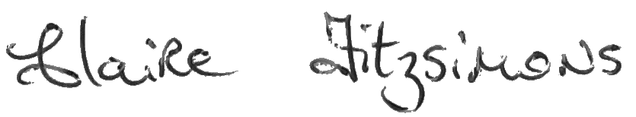
 | Date of issue: |  |  |  |  | 21/05/2021
 | Official Stamp:
 | 